
Contact:
Renée Becher
info@bailiwickpress.com
(970) 672-4878

FOR IMMEDIATE RELEASE
Ignoramus issues into bookstores December 2013
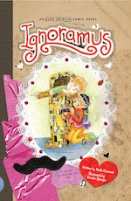
Ninth title in the award-winning Aldo Zelnick series will leave you irrevocably infatuated.
(Fort Collins, Colorado, November 2013)—
Ignoramus, an Aldo Zelnick Comic Novel, is now available from Bailiwick Press. An illustrated novel for middle-grade readers, Ignoramus continues the laugh-out-loud adventures of 10-year-old Aldo Zelnick. If there’s a more inopportune date for an elementary school boy to have a birthday than February 14th, Aldo Zelnick wants to know what it is. With his 11th birthday—and Valentine’s Day—fast approaching, Aldo plans a guys-only party with absolutely no pink, lace, or hearts, thank you very much. But what will happen if the girls, who all seem to have a crush on Aldo’s friend, Danny, crash the party?

Accolades for the Aldo Zelnick Comic Novel Series:
- 2010 Colorado Book Award, juvenile literature
- 2010 Mountains & Plains Independent Booksellers
Association Regional Book Award
- Winter 2010 Kids’ Next Indiebound Selection
- 2011 Independent Publisher Silver “IPPY” Award
- 2011 Creative Child magazine Preferred Choice Award
- 2011 Moonbeam Children’s Book Award, Silver Medal
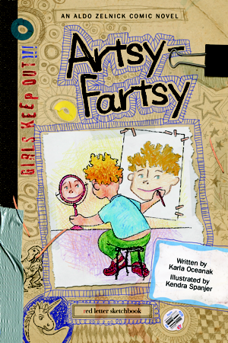
- 2011 Top 10 Educational Children’s Products—Dr. Toy
- 2012 Creative Child magazine Book of the Year Award, kids’ fiction
- 2012 Moonbeam Children’s Book Award, Silver Medal
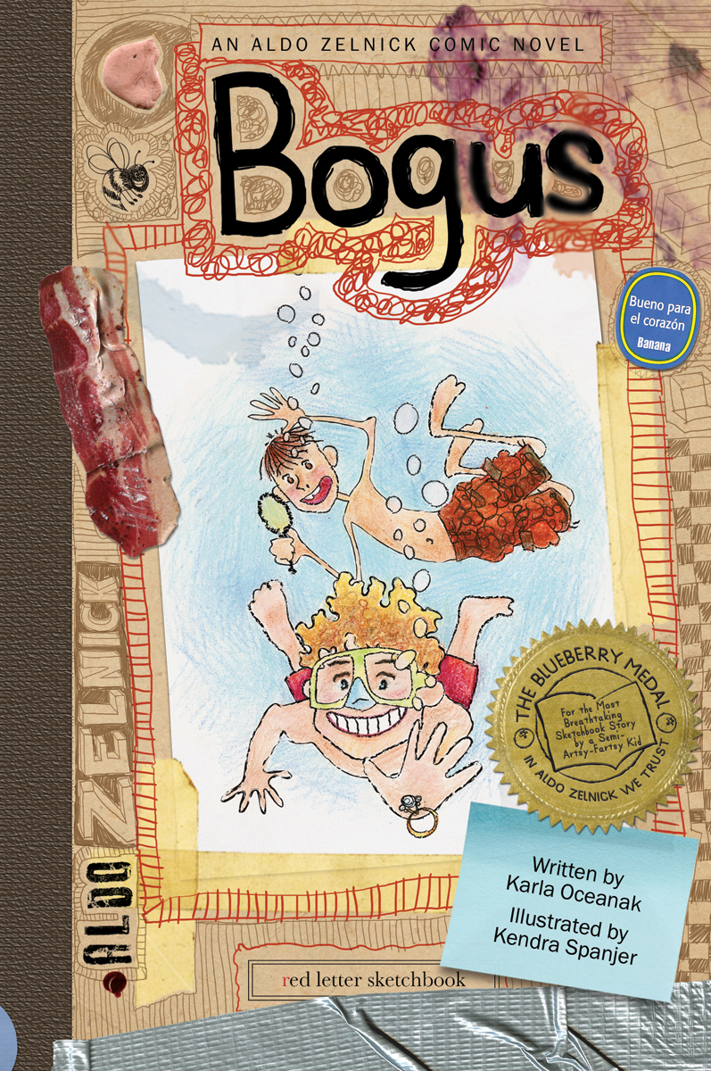
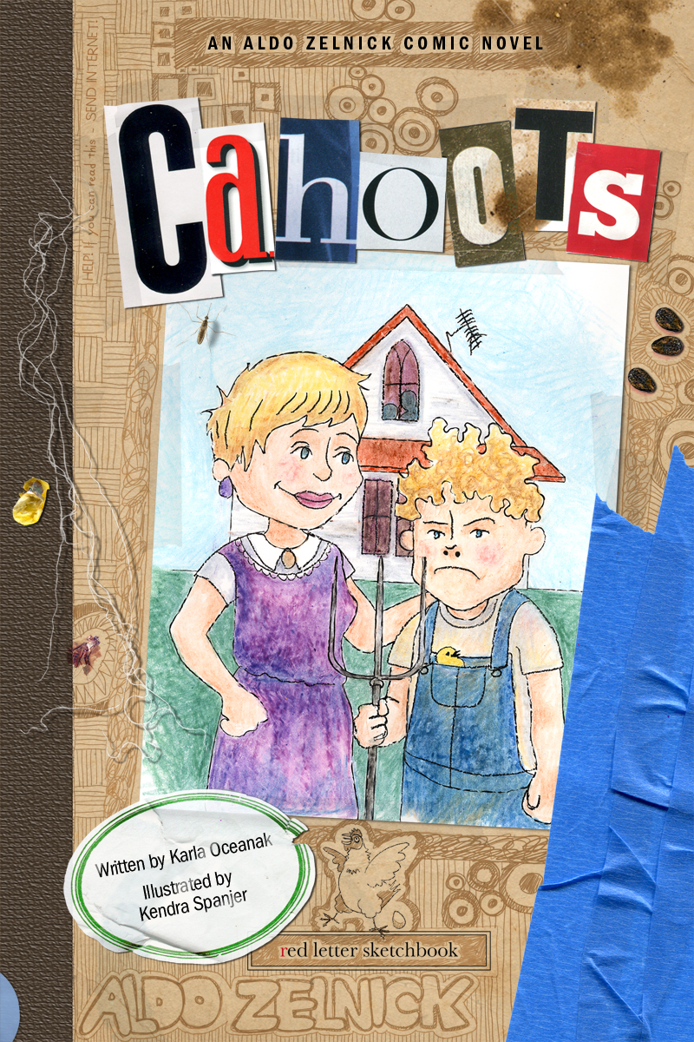
The Aldo Zelnick books, hardcover novels for 7- to 13-year-olds, feature the hybrid half-text, half-illustration format made popular by the Wimpy Kid series. The series stars 10-year-old Aldo Zelnick, a budding artist who hates physical activity but loves bacon. When Aldo’s grandmother gives him a blank sketchbook for recording “all his artsy-fartsy ideas,” a reluctant Aldo begins writing and drawing the story that becomes the first book in the alphabetical series, Artsy-Fartsy.
Unique to this series is the emphasis on vocabulary. Each book seamlessly integrates fun and challenging words starting with the title letter. Ignoramus features hilarious I words such as idiosyncratic and incorrigible. Each book also includes a back-of-the-book glossary with the words aptly (and amusingly) defined—and sometimes illustrated—in Aldo’s voice and hand.
The Aldo Zelnick series is beloved by kids, parents, teachers, and librarians alike:
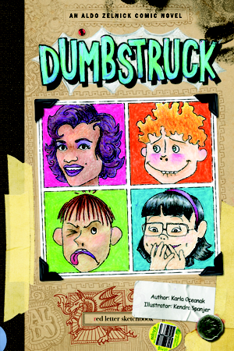
“Every library that serves Wimpy Kid fans (which is every library, period) should have the Aldo Zelnick series on its shelves.”
— Katie Ahearn, children’s librarian, Washington, DC
“This book will appeal to kids not yet ready for the middle-school life portrayed the “Diary of a Wimpy Kid” series but who have aged out of the irreverent potty humor of the “Captain Underpants” series.”
— School Library Journal, on Cahoots
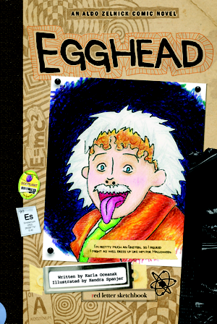
“These are books that definitely speak ‘kid speak.’ They’re perfect for reluctant readers and will be appreciated by parents and teachers for the amusing 'back door' approach to enriching vocabulary. Look out Wimpy Kid!” — Stacy Morris, Katy Budget Books, Houston, TX

“Aldo’s voice rings true from every page. The drawings are hilarious and enhance the text with visual humor that make Aldo’s personality pop right off the page. I’m predicting this series will be very big.” — Rebecca McGregor, librarian and curator of PictureLiteracy.com
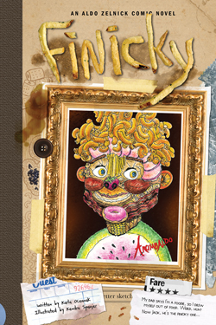
“I absolutely adore this series. Aldo is hilarious but absolutely real, a kid you could almost imagine walking through your front door at any minute.” — Danielle Smith, mom and children’s book blogger
“Creative, quick, unique and full of great illustrations. Aldo, Jack and Bee are always getting into crazy situations, and it’s a blast to read about them.” — Maya McQueen, YA Books Central

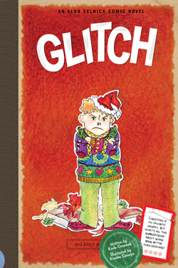
“I’ve been waiting for a series to come along that could knock Wimpy Kid off its pedestal as the most popular series in my library. Well, this may be it: the Aldo Zelnick Comic Novels. This is an action-packed alphabet series with laugh-out-loud, smart, fast-moving stories. The slapstick comic illustrations provide spot-on kid humor. ”
— Donna Dannenmiller, Teacher-Librarian, Olympia, Washington

"My son devours the Wimpy Kid books but said he likes the Aldo Zelnick books better because they’re funnier. I like them better because they make kids think. It's fun to hear giggles coming from the family room and my son is NOT watching TV.”
— Katie Maguire, mom to 11-year-old Shane
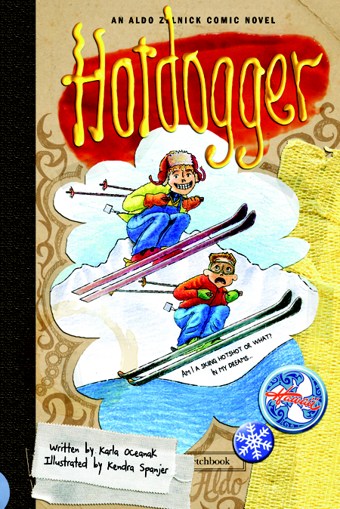
Series author Karla Oceanak has been a writer and editor for more than 20 years and speaks on children’s literacy. Illustrator Kendra Spanjer is also a studio artist. Bailiwick Press is a new micro-press specializing in humorous yet meaningful fiction for children and young adults.
For more information, visit www.bailiwickpress.com and www.aldozelnick.com. To request a complimentary review copy, e-mail renee@bailiwickpress.com.

Ignoramus, written by Karla Oceanak, illustrated by Kendra Spanjer, ISBN 978-1934649411, published by Bailiwick Press, distributed by Independent Publishers Group, available December 2013, $12.95 U.S. / $13.95 Canada, children’s fiction, hardcover, 160 pages, 6.25” x 9.25”, 150 black and white illustrations.

